Borehole No. GM74
Location Nsareye, Afram Plains
Latitude N 07°01.823’
Longitude W000°34.809’
Date started 22/01/2000
Date completed 24/01/2000

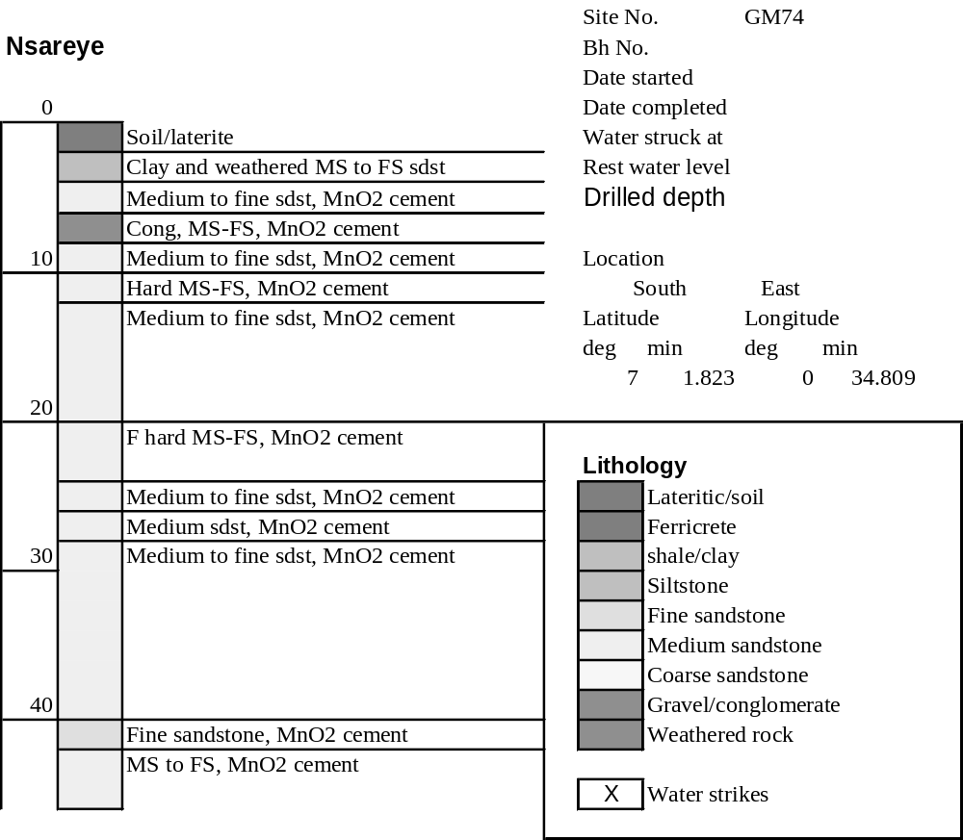

Summary Lithological Log
Depth(m)
From To
0 1 Soil/laterite
1 3 Sandy clay and weathered medium to fine sandstone
3 4.1 Very hard medium sandstone with manganese cement
4.1 6.1 Medium to fine sandstone with manganese cement
6.1 9.1 Conglomerate with medium to fine sandstone and manganese cement
9.1 10.2 Medium to fine sandstone with manganese cement
10.2 12.2 Hard to fairly hard medium to fine sandstone with manganese cement
12.2 20.3 Medium to fine sandstone with manganese cement
20.3 23.4 Fairly hard medium to fine sandstone with manganese cement
23.4 26.4 Medium to fine sandstone with manganese cement
26.4 28.4 Medium sandstone with manganese cement
28.4 33.5 Medium to fine sandstone with manganese cement
33.5 34.5 Fairly soft medium to fine sandstone with manganese cement
34.5 40.6 Medium to fine sandstone with manganese cement
40.6 41.7 Fine sandstone with manganese cement
41.7 44.7 Medium to fine sandstone with manganese cement

Detailed Lithological Log
Depth(m) Lithology
From To

Soil/laterite
0 1 White, light grey and orange yellow to pink clayey top soil
1 2 Light grey to light brown clayey soil with some black manganiferous
partings

Sandy clay and weathered medium to fine sandstone
2 3 Red brown and orange sandy clay above friable purple black and pink
medium to fine grained sandstone

Very hard medium sandstone with manganese cement
3 4.1 Very hard pink and black medium sandstone with black mica like Mn
oxide cement, silicified?, above softer dark red/brown and black
medium to fine sandstone with much black Mn oxide

Medium to fine sandstone with manganese cement
4.1 5.1 Dark red/brown friable medium to fine sandstone with orange/pink
grains and black Mn oxide cement
5.1 6.1 Light pink grey medium to fine sandstone with little Mn alternating
with dark red medium to fine sandstone with orange pink grains and
much black Mn oxide cement

Conglomerate with medium to fine sandstone and manganese cement
6.1 7.1 Light pink/grey and white granitic sandstone fragments from a
conglomerate with dark red/brown medium to fine sandstone with
weathered orange pink grains and black MnO cement
7.1 8.1 Light pink/grey and white fine to medium granitic fragments from a
conglomerate with dark red/brown medium to fine sandstones with
some pink grains and much black MnO cement
8.1 9.1 Light pink/grey and white fine to medium granitic fragments from
conglomerate with dark red/brown medium to fine sandstones with
some pink grains and much black MnO cement

Medium to fine sandstone with manganese cement
9.1 10.2 Dark red/brown medium to fine sandstone with pink grains and black
MnO cement - less than above, no granite frags but odd thin layer of
green/blue/grey mudstone or chlorite

Hard to fairly hard medium to fine sandstone with manganese cement
10.2 11.2 Hard interbedded dark purple/red medium to fine sandstone with black
MnO cement and light purple and grey medium granitic sandstone with
some white mica.
11.2 12.2 Fairly hard red/brown medium sandstone with many pink grains and
black MnO cement fairly hard medium to fine grained sandstone
mainly dark red/brown with pink grains and black MnO cement but
interbedded with lighter reddish orange and pink sandstones with no
MnO

Medium to fine sandstone with manganese cement
12.2 13.2 Thinly bedded dark red/brown medium to fine grained sandstone with
black MnO cement and some pink grains
13.2 14.2 Dark purple/red medium to fine grained sandstone with odd orange
rounded grains, much black MnO cement
14.2 15.2 Dark red/purple to black medium to fine grained sandstone with pink
grains and black MnO cement
15.2 16.3 Dark red/pink medium to fine grained sandstone, fairly hard with pink
grains and black MnO cement
16.3 17.3 Dark red/pink and black medium to fine grained sandstone, fairly hard
with pink grains and black MnO cement
17.3 18.3 Dark red/brown medium to fine grained sandstone with orange/pink
grains and decreased black MnO cement, some platy fragments of
red/brown mudstone
18.3 19.3 Dark pink/red and black medium to fine grained sandstone with pink
and red grains and much black cryptocrystalline and cement MnO.
Odd platy fragment of green grey chlorite from a fracture?
19.3 20.3 Dark pink/red medium to fine grained sandstone with pink/orange
grains and black MnO cement

Fairly hard medium to fine sandstone with manganese cement
20.3 21.3 Red/black manganiferous medium to fine grained sandstone, fairly
hard platy fragments with crystalline MnO
21.3 22.4 Dark pink/red fairly hard medium to fine grained sandstone with pink
grains and some black MnO cement, with much lighter sandstone with
no MnO cement
22.4 23.4 Dark pink/red fairly hard medium to fine grained sandstone with pink
grains and some black MnO cement; alternating with black and red
manganiferous fine grained sandstone with purple grains and much
black MnO cement

Medium to fine sandstone with manganese cement
23.4 24.4 Dark red/brown, pink and black medium to fine grained sandstone with
pink angular grains and black MnO cement
24.4 25.4 Dark red/brown medium to fine grained sandstone with some pink
grains and little black MnO cement
25.4 26.4 Dark red/brown medium to fine grained sandstone with some pink
grains and little black MnO cement

Medium sandstone with manganese cement
26.4 27.4 Hard dark red/black medium sandstone with pink red grains and much
black MnO cement and cryptocrystalline form
27.4 28.4 Hard dark red/black medium sandstone with pink red grains and much
black MnO cement and cryptocrystalline form

Medium to fine sandstone with manganese cement
28.4 29.5 Dark red/brown medium to fine grained sandstone with some pink
grains and little black MnO cement
29.5 30.5 Dark red/brown medium to fine grained sandstone with some pink
grains and black MnO cement; with lighter light brown/pink and grey
sandstone bands with greenish grey chlorite
30.5 31.5 Dark red/purple medium to fine grained sandstone with pink grains and
black MnO cement
31.5 32.5 Dark red/purple medium to fine grained sandstone with pink grains and
black MnO cement with odd green grey shale like fragment
32.5 33.5 Dark red brown medium to fine grained sandstone with pink grains and
black MnO cement; subordinate orange and grey medium to fine
grained sandstone granitic

Fairly soft medium to fine sandstone with manganese cement
33.5 34.5 Purple brown and black fairly soft manganiferous medium to fine
sandstone, platy fragments

Medium to fine sandstone with manganese cement
34.5 35.6 Dark red/black medium to fine grained sandstone with some pink
grains and black MnO cement, fairly hard
35.6 36.6 Dark chocolate brown medium to fine grained sandstone with black
MnO like mica grains and cement especially along bedding planes
36.6 37.6 Dark chocolate brown medium to fine grained sandstone with black
MnO like mica grains and cement especially along bedding planes
37.6 37.6 Dark red brown medium to fine grained sandstone, platy fragments,
some pink grains and black MnO cement
37.6 38.6 Dark red brown medium to fine grained sandstone, platy fragments,
some pink grains and black MnO cement
38.6 39.6 Dark brown and black manganiferous and iron rich medium to fine
grained sandstone with some finely crystalline MnO as well as black
cement
39.6 40.6 Dark brown and black manganiferous and iron rich medium to fine
grained sandstone with some finely crystalline MnO as well as black
cement; with odd fragment of light grey fine grained sandstone

Fine sandstone with manganese cement
40.6 41.7 Dark brown/black fine grained sandstone with black MnO cement

Medium to fine sandstone with manganese cement
41.7 42.7 Dark red/brown medium to fine grained sandstone with pink grains and
black MnO cement
42.7 43.7 Dark red/black fine grained manganiferous sandstone with subordinate
dark red/brown medium to fine grained sandstone with pink grains and
black MnO cement
43.7 44.7 Dark red/brown medium to fine grained sandstone with pink grains and
black MnO cement

